April 25, 2017

Premium Processing Service
U.S. Citizenship and Immigration Services
California Service Center
ATTN: I-129
24000 Avila Rd.
2nd Floor, Room 2312
Laguna Niguel, CA 92677

Detailed India Manager Letter

I have been Vishal Ramesh Bhardwaj’s manager in India since February 2015 during all relevant events, and therefore I have personal knowledge of the following facts:

The Beneficiary’s acquisition of specialized knowledge in the Petitioner’s unique tool

Mr. Bhardwaj joined Synechron Technologies Private Limited in August 2012. Mr. Bhardwaj obtained his specialized knowledge of our proprietary SyneMobiSafe outside the United States.

Mr. Bhardwaj gained his advanced level of specialized knowledge of Synechron’s SyneMobiSafe by designing its major foundations for Synechron from February 2015 to February 2016. His duties for SyneMobiSafe’s module design can be broken down as follows:

- Data Backup: Vishal Bhardwaj designed this module as an automatic and real time cloud data backup solution. To achieve this, he wrote the complex algorithm to ensure that as soon as new images or contacts are added to the device, a system-level event is triggered and the files/contacts are uploaded to the remote server on a background thread. He has developed the algorithm in such a way that before the actual upload starts, all the files' metadata are gathered and an exchange happens between the server and the device to check if similar files are already backed up (saved or deleted). Along with this, he also managed the user configurable settings, backup frequency, network and OS-level restrictions that makes the logic more complex before uploading the files to the cloud server. (20% of work time)

- Device Protection & Security: Mr. Bhardwaj performed the technical design and implementation of this module. He designed this module to track the malicious files copied to the device along with the capability to detect side loaded apps. As the application runs, a service is initiated to scan the complete file storage and analyze the signature (binary makeup) of each file for match or partial match against a database of known viruses and trojans. If a match is found, the user is notified and can choose to delete the file or ignore it. Integration of custom signed certificate chain is also implemented to prevent man-in-middle attacks, so when the application is launched, it first checks the validity of the SSL handshake between the server and progresses only after successful authentication. A service is also implemented as a background thread to detect if any phishing website is being accessed by the user on the device browser. It matches the URL entered against a list of known threats and warns the user by showing proper message on the UI. (10% of work time)

- Device Recovery: Mr. Bhardwaj developed the Device Recovery module, which has a vital role in locating and managing mobile devices in case of theft or misplace. He developed this module based on push notifications and the functionality is a successful implementation based on an effective communication between mobile device, backend, and cloud server. He wrote components that track the cloud server for any incoming messages. An API call is triggered to the backend server to fetch the next course of action and based on that it performs necessary operations. Depending on the actions (lock/sound/wipe), necessary classes and methods are invoked to sound an alarm on the device, or to lock it, or to wipe the data. For locate action, GPS-related classes are used and location services are enabled to collect the device's current location coordinates and sends across to the backend via API calls. (10% of work time)

- Device Health Monitoring: Mr. Bhardwaj designed this module for device monitoring to enable users to keep track of applications and other services slowing down the performance of the device. The user is provided with the options to perform speed, storage, and battery scan as a part of user interface and once any of these actions are performed, a service is executed and an algorithm kicks in to collect information for the installed apps. For speed, the algorithm detects number of processes running on the device and consuming a lot of memory and in the process slowing it down. Similarly, records are generated for applications consuming large storage space and absorbing a lot of battery. Once this information is available, user is notified with a list of applications hampering the device performance. (10% of work time)

- Telemetry and Data Analysis: Mr. Bhardwaj designed this module as a one-stop solution for effective data analysis. The functionality is written in such a way that a service component keeps running in the background to gather user data and a job is scheduled to transfer it to the remote server after every specific interval. The user’s device settings and application configuration (like report size, number, and transmit frequency) have also been considered for the working of the module. On the backend, depending upon the criticality (i.e. low memory storage, app crashes, etc.) of the input data and business rules, user insights, i.e. standard HTML templates are generated and stored on the server and a notification is sent to the device along with its content URL. On the device, once the message is received, the URL is fetched from the notification response and the report is displayed on the web view. (20% of work time)

- Advanced Technical Support with Live Chat: Mr. Bhardwaj designed this module to provide a customer-centric experience and a real-time problem solving mechanism to the end users. As the application runs, a service call is made to initiate a request on server for authentication with a unique id and after successful authentication, same id is used for initiating a request for access on the remote channel. The remote API channel is designed in such a way that tech agents can view device screens to give and maintain a seamless user experience. If agents are not available, callback interfaces are also implemented that communicates the reason for agent’s unavailability to the users and proper error messages are displayed to the user. For the chat feature, push notification is implemented, and all the necessary components like cloud server service and broadcast receiver are integrated beforehand, so as soon a message is received, the response is parsed and a notification is created using an intent and displayed on the UI panel. (20% of work time)

- KIA (Know It All): Mr. Bhardwaj designed the KIA module, which is a knowledge-based module that enables users to get device-related articles and tips on the go along with custom searches. The module is implemented in such a way that it runs a job to gather the device data like make, model, and OS version across its users’ base, and with a complex algorithm, generate custom articles/tips (HTML content) specific to the users' device and sends it as a notification containing the article URL. For search functionality, the keyword is sent as service request and looked-up into articles repository and if available, content/article URL is delivered to the user as a response. If not, depending upon certain requirements like number of times that keyword is searched, an article is generated and stored on the repo so that it can be useful for later searches. (10% of work time)

Compare and Contrast Duties with his India team:
Mr. Vishal Bhardwaj’s India team consisted of Prateek Patel, Prajakta Naringe, Yoganand Chillale and Pavan Kulhalli. Their duties that were insufficient to impart any advanced knowledge of Synechron’s SyneMobiSafe, was as follows:

- Design test scenarios and validation (20% of their daily work time)
- Design User Interface for the application (20% of their daily work time)
- Automation test data creation (10% of their daily work time)
- Test integrated components of the application (30% of their daily work time)
- Checking for memory leaks and code validation (10% of their daily work time)
- Debugging of application (10% of their daily work time)

These duties do not reflect any advance knowledge on Synechron’s SyneMobiSafe.

Mr. Bhardwaj has been applying his advanced knowledge of our SyneMobiSafe since March 2016 till present while working on the following project in India.

Project 1: Protection App (Asurion), March 2016 - Present

- Mr. Vishal Bhardwaj applied his specialized knowledge of Synechron’s SyneMobiSafe and played a critical role in architectural enhancement of the SyneMobiSafe tool by providing a comprehensive mobile solution including security, protection, tech support, and other value-added services in mobile insurance domain. Mr. Bhardwaj redesigned the user interface of SyneMobiSafe to meet various functional and non-functional requirements. The enhancement of SyneMobiSafe tool also included simplification of user interface, consistent use of UI components, views and layouts, and strategic use of colors and icons for displaying alerts, notifications, and messages. He also used his advanced knowledge of the tool for the environment setup, integration among the modules of the tool, and configuration of the same. (30% of his daily work time)

- Mr. Vishal Bhardwaj applied his specialized knowledge of Synechron’s SyneMobiSafe by redesigning and reviewing architectural-level templates of each module along with its technical feasibility. Mr. Bhardwaj also identified the compatibility challenges, initial design errors, and integrity factors for coherent development to make a cohesive SyneMobiSafe tool. Mr. Bhardwaj also focused on the enforcement of adhering to Synechron’s development guidelines to ensure proper implementation and integration of different functional modules of the tool. (40% of his daily work time).

- Mr. Vishal Bhardwaj used his specialized knowledge of Synechron’s SyneMobiSafe to identify critical business scenarios that were a road block for Synechron’s SyneMobiSafe tool and provided the solution architecture for technical support, telemetry, error handling, data storage, device protection, and its security (25% of his daily work time).

- Mr. Vishal Bhardwaj worked on creation of methods, Built-In functions, automated build generation, folder creation for version control and data back up, and the code compilation of the Protection Application during its initial development phase to minimize errors and ensure quality of the Protection Application. (5% of his daily work time)

Mr. Vishal Bhardwaj relied on his advanced knowledge of Synechron’s SyneMobiSafe tool in performing his duties on this project.

Compare and Contrast His India Team’s Duties:
Mr. Vishal Bhardwaj’s India team consisted of Prateek Patel, Prajakta Naringe, Yoganand Chillale and Pavan Kulhalli. Their duties, which did not require or convey any advanced knowledge of Synechron’s SyneMobiSafe tool, were as follows:

- Created user interface and new branding (20% of their daily work time)
- Created various test scripts and perform peer reviews of test cases (20% of their daily work time)
- Created required test data and run already created integration test scripts. Prepared and published daily test report (10% of their daily work time)
- Performed dry test run on a regular basis after development and integration of each module and as per new changes as and when implemented. (30% of their daily work time)
- Performed code validation and used custom tools to check for any memory leaks throughout the application (10% of their daily work time)
- Performed debugging of the application to look for any potential crash and application breakdown (10% of their daily work time)

Mr. Vishal Bhardwaj’s salary in India has been 1172644 INR per annum, whereas the average salary for his classification is only 800181 INR per annum. This premium salary was due to his advanced knowledge of Synechron’s SyneMobiSafe tool. Further, due to his exceptional contributions regarding SyneMobiSafe for our company, Mr. Bhardwaj was nominated for Synechron’s Surpass Award for the period of January 2016 – March 2016.

The unique and complex features of the Petitioner’s tool:

SyneMobiSafe is Synechron’s complete mobile solution tool whose objective is to provide data management and advanced customer support features, such as backup and restoration of contact and content data; recovery options like locate, lock, wipe, and alarm; security options such as antivirus and malware detection; and advanced mobile technical support services. SyneMobiSafe can enhance the user experience and deliver exceptional value to subscribers by using state-of-the-art analytics to provide a one-stop shop for not only resolving device issues, but also assisting users on how to manage their content and become more productive with their digital devices.

SyneMobiSafe provides effective and instant mobile technical support through a streamlined and simplified approach to customer-agent interactions. This helps enterprises to extend productivity through an unmatched customer service. It also allows businesses to manage customer experience and operational efficiency by appointing users to the most proficient and unoccupied agent suitable for the interaction.

This can be achieved by:
- Determining what steps to take, in what order, on what device given a very wide range of settings.
- Relying on someone with strong technical background with a complete know how and who can perform right actions.

SyneMobiSafe provides a mechanism that allows tech agents to perform certain actions enables them to access user's device remotely and operate it. Agents can also draw some basic shapes on the device screen indicating the users to navigate through the settings menu and guide them to solve and fix the issues they are facing. This not only ensures that the problem is resolved, but also saves a lot of user’s time spent on interacting with the customer agents.

Mobile devices are particularly susceptible to reverse-engineering attacks and threats at the application-level, data/storage-level, and web-level. It is imperative to have an application that provides built-in security controls self-defense mechanisms that account for such threats and the limitations of a device OS limitations.

SyneMobiSafe considers all this and offers a multilayer protection including:

- Antivirus protection
- Detecting phishing and malware websites, it and alerts the user if they are trying to access it on mobile web browser
- Real-time protection, including intrusion prevention and alerts that an attack/threat is in progress.

Telemetry implementation is an updated approach to the transition of mobile applications and is the need of the day. Based on a deep understanding of telemetry options and careful data analysis, we have developed a telemetry architecture that enables SyneMobiSafe to process information around user metrics, application data, crash reports, and a lot of other statistics about the device. It also gives the ability to query big data and generate insights (from large scale user’s data), which is delivered to them via proper channels like notifications.

The following is a high-level architecture diagram of SyneMobiSafe, its module architecture, and its workflow:

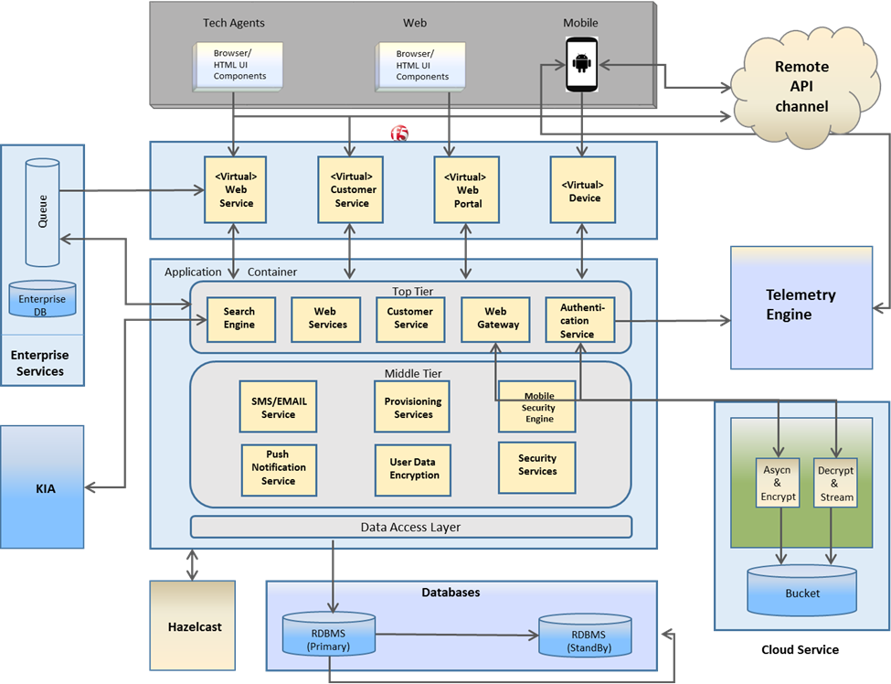
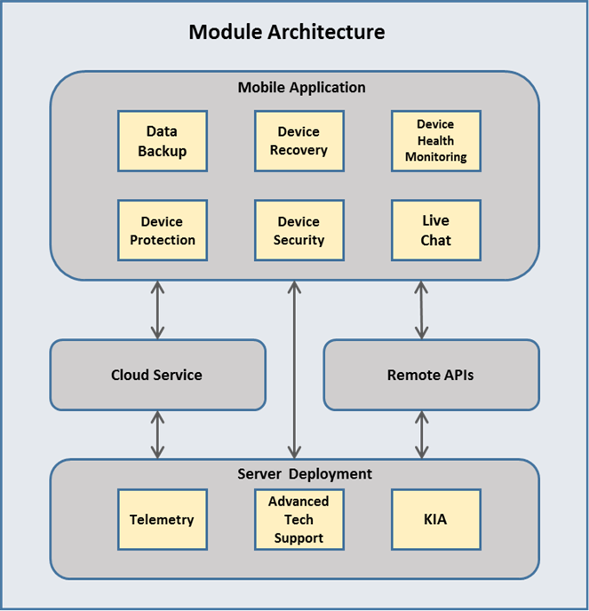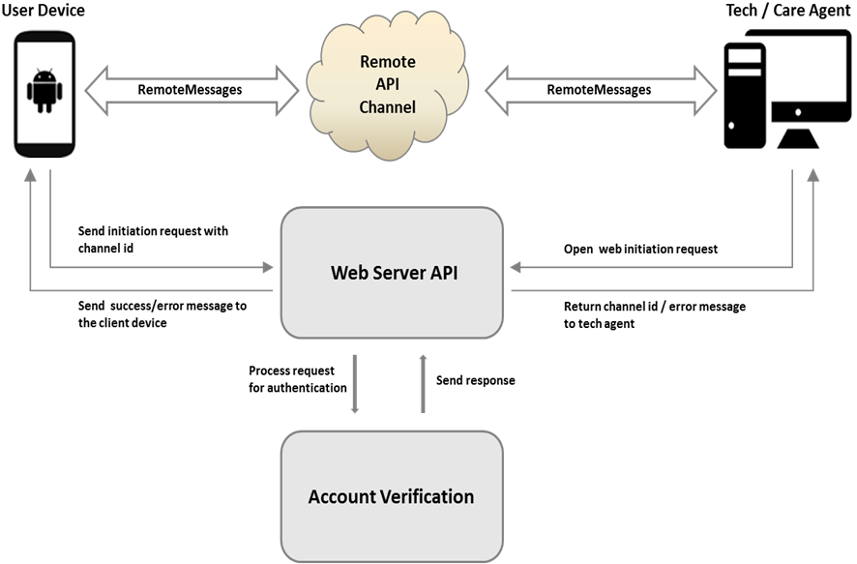
SyneMobiSafe is highly complex and consists of various modules. The following are the main modules of SyneMobiSafe. Please refer to the enclosed whitepaper for further details:

Module 1: Data Backup
This tool provides a backup system that is smart enough to take back up of that data, which has not been backed up. There is a complete algorithm that ensures cross-checking of numbers of file and types of files on the cloud and on the device, storage space, network restrictions, OS settings, and other user-defined configurations, before initiating a backup. Apart from these stringent configurations, the tool ensures that data transfer occurs in a secure manner and offers enhanced security options including data encryption.

Module 2: Device Protection & Security
The application enables secure mobility by providing risk management across Android devices to protect against network, app, and device-based vulnerabilities while providing visibility and control over data breach. It includes a comprehensive suite that enables the users to leverage its capability to provide security against malware, viruses, phishing sites, Trojans, etc. It also has a feature that warns the users against a possible phishing or malware website, if they are visiting any URL on the device browser.

Module 3: Device Recovery
Recovering a device is another integral aspect for a complete mobile solution as it enables the users to have full control of their device even if it's not with them (in case of theft or misplaced). This functionality consists of features such as Locate, Alarm, Lock, and Wipe.

Module 4: Device Health Monitoring
One of the most important things that always keeps a user engaged in an application is how it lets you know how healthy your device is. SyneMobiSafe enables users to scan through apps and data storage to gather information and run a complex algorithm to conclude the device and battery performance, which is helpful in identifying and resolving battery-related issues. It also indicates which apps are running high on memory, ones who use a lot of storage space and about the ones who consumes a lot of battery.

Module 5: Telemetry and Data Analysis
Mobile device telemetry data is a main information source for personalized engagement and it measures the real-time user experience. We use unique, big-data analytics to associate the anonymized device data with customer context to generate reports and enable personalized engagement that is timely, relevant, and actionable for the users. This is how data is collected (high-level) and sent across the servers. Telemetry data is uploaded from the device to a cloud-based analytics system. Collection and transmission of device telemetry are optimized to balance frequency of collection for obtaining up-to-date information with minimizing battery drain and data volume.

Module 6: Advanced Technical Support with Live Chat
SyneMobiSafe provides flexibility to the users to opt for instant tech support or go for live chat depending on the urgency and complexity of the issues they are facing. They can chat with care agents and communicate the problems they are struggling with or they can contact tech agents who can remotely access their device to fix issues and provide expert tech assistance and resolution.

Module 7: KIA (Know It All)
KIA is a knowledge-based value-added feature that enables SyneMobiSafe users to get tips and other articles with relevant information they might be seeking about their device or it may be related to any technical issue they are facing with their mobile phones. They can also perform a search for anything related to their device, ranging from security settings to Bluetooth or Wi-Fi connection issues and if available, a content-rich article will be provided to them containing step-by-step details.

SyneMobiSafe comes as an all-in-one package to provide a cutting-edge mobile solution offering unique capabilities and broad ranging functionalities to its end users. It not only helps in securing users' personal content on their devices but provide advanced troubleshooting options too. The overall product initiative is to create a compelling application which is an integration of cloud services, device security and protection, device recovery, health monitoring and advance technical support services and deliver an all-in-one mobile solution offer. In addition, SyneMobiSafe enhances mobile experience and satisfaction and provides value-added services for the end users.

With its robust analytics, rules engine, and services, SyneMobiSafe is differentiated from other competitors and enables any enterprise to be established as a reputed partner for their customers. The combination of all the functionalities and services makes it an excellent product that is inimitable and uses latest technology to provide value to its users.

SyneMobiSafe can furnish multiple business opportunities and can be seamlessly integrated with enterprises dealing into mobility. These can be carrier operators, or big mobile insurance providers who can equip their customers with this application (hard bundled to their mobiles) that can provide a comprehensive mobile solution for their needs and at the same time, be a cost-efficient approach to address business potential and enable business growth. The following are potential business advantages that can be achieved by implementing SyneMobiSafe:

  - Enhance existing customer relationships
- Improve customer experience with efficient and effective tech support
- Provide user-specific data analysis and timely action reports
- Improve availability and stability of business

  - Reduced incident handling cost
- Timely identifying and resolving issues brings down this resource consuming process significantly.

  - Enable growth opportunities
- Support subscriber growth with real-time user experience

  - Business Agility (detect and respond effectively and efficiently)
- Aims to enable understanding, inform decisions, and enhance business agility

Mr. Bhardwaj’s work will be controlled by our company; no client may provide more than occasional feedback. He will report to our company’s supervisor, Mr. Nilesh Dharmadhikari, Senior Manager – Software for Synechron.

Sincerely,
Synechron Technologies Pvt. Ltd.

Anurag Bhargava
Director - Software

